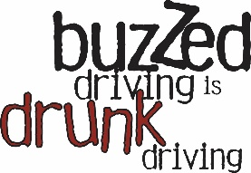

Buzzed Driving Is Drunk Driving Social Media
Facebook, X, Instagram
When posting to X and Instagram, consider adding trending or relevant hashtags, like #BuzzedDriving #DrunkDriving or #DontDrinkandDrive, to any of the below posts:

- Plan ahead before you DRINK 🍻. Even a small amount of alcohol can affect driving ability. BUZZED Driving is DRUNK Driving.

- If you have to ask, “Am I okay to drive?” The answer is always NO ❌. Remember: BUZZED Driving is DRUNK Driving.

- DID YOU KNOW ❓ You begin to feel the effects of alcohol at a BAC under .08. Alcohol consumption impairs your thinking, reasoning and muscle coordination – all vital to operating a vehicle SAFELY 🚘✔️.

- Getting behind the wheel after 1️ too many drinks can lead to DISASTER 🚑🏥. Always remember, Buzzed Driving Is Drunk Driving. Find tips to keep you and others safe at NHTSA.gov.

- Don’t plan to DRINK 🍻 without a plan to get home SAFELY 🔑 🏠. Your life and the lives of others are at risk every time a driver gets behind the wheel after drinking.

- You can help put the BRAKES 🛑 on drunk driving deaths:
🚕 Before drinking, designate a sober driver or schedule a ridesharing or taxi service.
🥤 🔑 If you’re hosting a party with alcohol, offer non-alcoholic drinks and make sure all guests leave with a sober driver.
🔒 Always wear your seat belt — it's the best defense against drunk drivers.
📲 If you see a drunk driver, safely pull over and call law enforcement.

